Team 1
InnerGreen
Integrate sustainability into the daily journey of every MTR user
Hazel O’Neil, Yujun Fan, Yuan Huang, Chun Hei Au Yeung, Zinuo Wu

The strategy develops a green urban “Acupuncture Toolkit” - strategic and scalable insertions to enhance older stations in the MTR network. The toolkit includes interventions such as a cultural-green corner for passengers to understand more about Hong Kong's local culture; video installations that bridge the transition from outdoor nature into stations; making long transition corridors more pleasant with greenery and floor graphics; benches in platform waiting areas to entertain and impress passengers while they are waiting for trains. MTR can not only enhance its sustainability strategy but also improve customer experience, rider retention and growth.

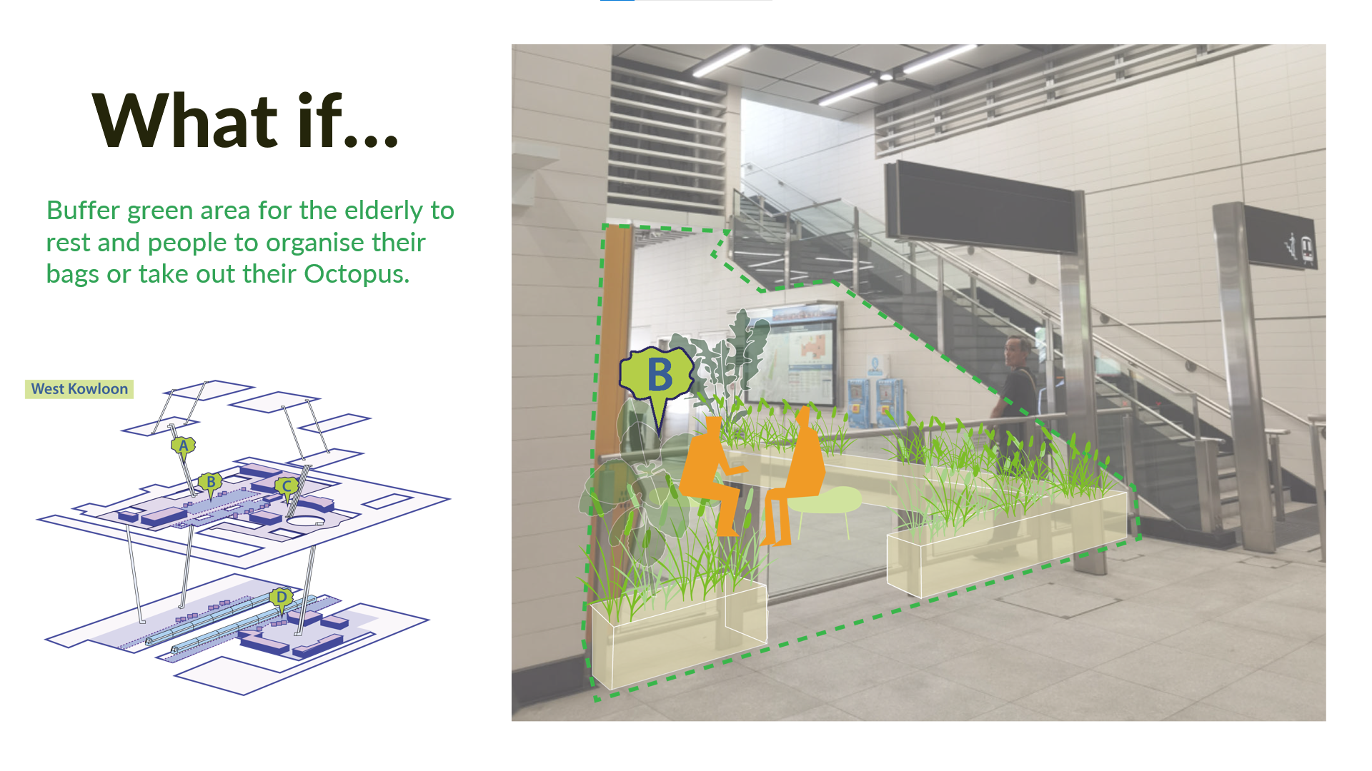

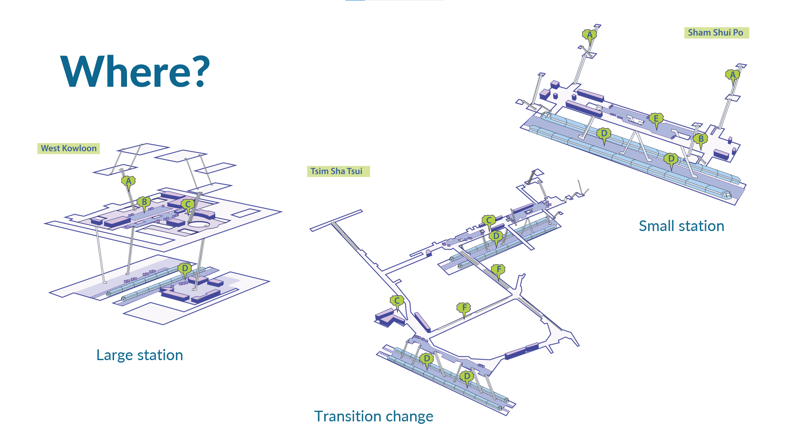
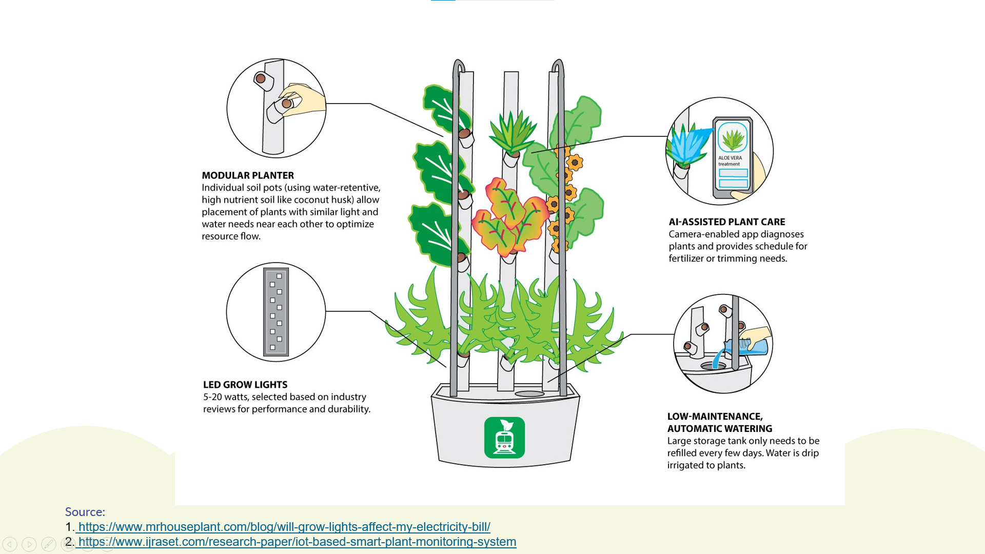

Team 2
Blockmall
Using state-of-the-art technologies (AR and AI) for digital marketing and visitor's personalization experience
Sarah Lohmar, Hoi Fung Chen, Ngai Man Lam, Jiaxin Liang, Adrianus Hans Viary

Modern malls need to be more than passive spaces. They should be vibrant social hubs that cater to the needs of communities. The most crucial aspect of our approach is giving customers a reason to share their experiences and happy moments on digital platforms, creating a second connection with their life cycle. We strive for active participation from all communities to elevate the spatial values in MTR malls. Our vision is to create lively and diverse MTR malls that connect people, commerce, social interactions, and entertainment.

BLOC Mall: Elevate Your Journey, Connect with Community.

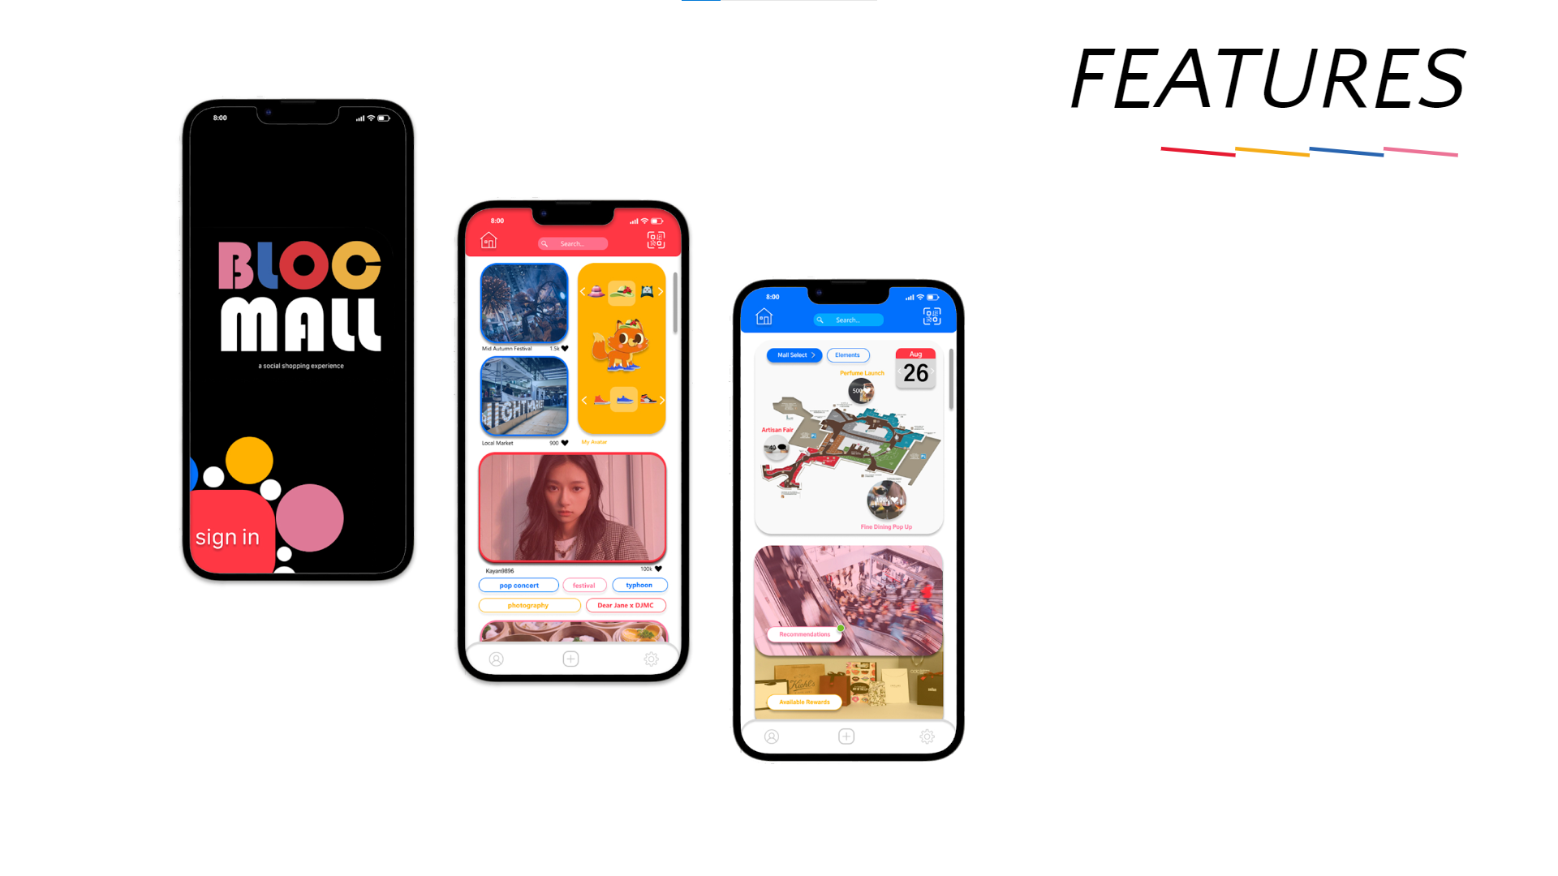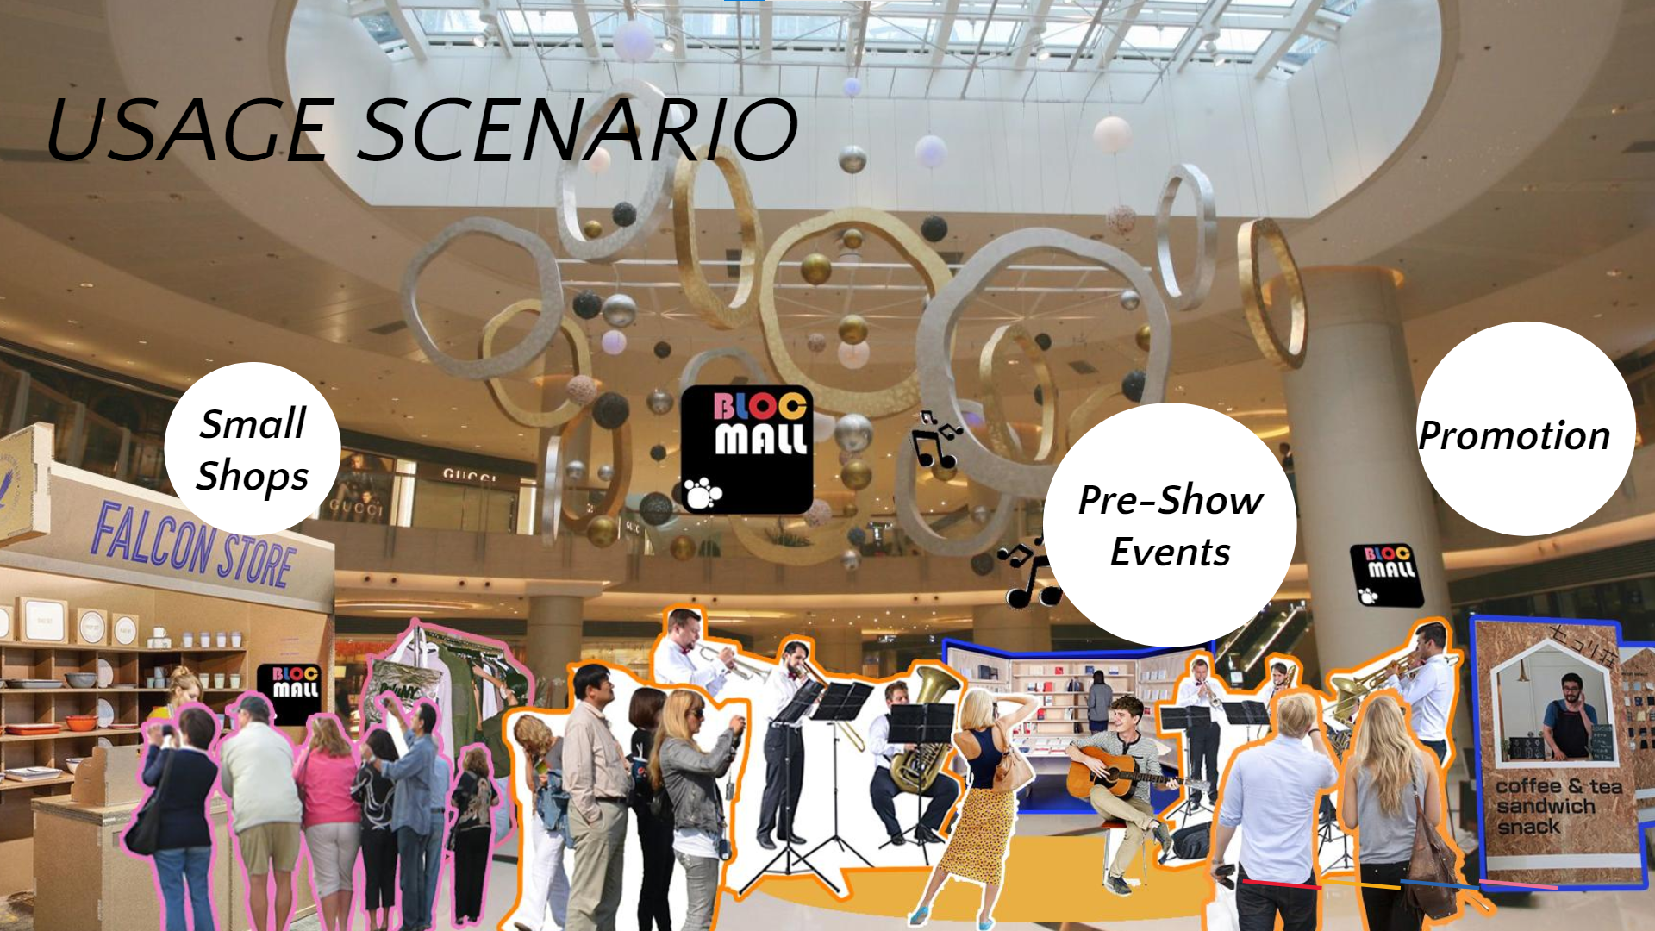

Team 3
Swiftsend
Low-carbon, fast, reliable, and low-cost freight delivery for everyone​
Hannah Shumway, Elizaveta Dorrer, Ricky Jinru Tian, Sze Fan Ng, Isabella Tasset

Swiftsend is an MTR startup that solves low-carbon, low-cost, fast, and reliable freight delivery – no trucks involved. To accomplish this vision, SwiftSend's ultimate goal is to start transporting cargo on MTR trains. In this way, the MTR could connect with the Greater Bay Area in the long term, transporting goods to and from nearby cities. SwiftSend provides faster and cheaper delivery for citizens, carbon footprint reduction for the whole planet, and extra revenue for MTR to keep delivering the best service.

Team 4
H2GO

Say goodbye to disposable plastic bottles and hello to sustainability with the convenient and eco-friendly reusable water pick up station — your solution for reducing waste and making a positive impact on the environment.
Emma Swarney, Tianze Li, Yi Lu, Yu-jui Tsao, Ka Ying Wong

H2GO introduces a hygienic pre-filled reusable water bottle borrowing scheme that is circular, efficient, and at a competitive price to the user. The user can use and tap their Octopus card, retrieve a reusable bottle, drink, and stay hydrated. Later the bottle is returned to the reusable bottle station at any grab & go station at the MTR. The Reusable bottle is sterilised at a cleaning facility, after that the sterilised bottle is filled again with water and loaded at a MTR station. Our strategy introduces an innovative hygienic solution, which is highly accessible to all passengers and motivates users to reduce unnecessary plastic waste.

Team 5
Embolden

Installation on demand community support via mobile connecting volunteers and those in need, with a physical honourable badge system to recognize kindness and spread the Hong Kong positive culture.
Nineveh O’Connell, Linxiao Li, Ky Nam Nguyen, Ziyi Xu

Our vision is to build the on-demand community help culture for those in need through a framework, integrated within a mobile app with a badge-reward system targeting both the elderly and young generations. Inspired by the London metro badge system - “please offer me a seat” - people will be able to identify those in need and those who can help them. Badges will come with personalised and creative design which makes it all more fun and help spread local culture. The concepts would collaborate with existing voluntary and non-profit organisations to boost impact.

Team 6
Woah!Woah! Woah!

Lowering passengers’ stress through managing the crowd and revitalising unused spaces in the transition stages by providing interactive and dynamic AR-based spaces.
Jonathan Goh, Stesya Aprilnity, Behnam Asadieh, Liangheng Hou, Tianyu Li

Rest is often underrated in our society, even though our bodies need downtime to recover and restore balance. Every person has a different pace, but in the MTR everything is rushed. What they would need is an opportunity and a driver to slow down without disrupting their trips or anybody else’s. For this reason, we propose a dynamic model which makes the MTR experience less stressful offering interactive experience with AR features.

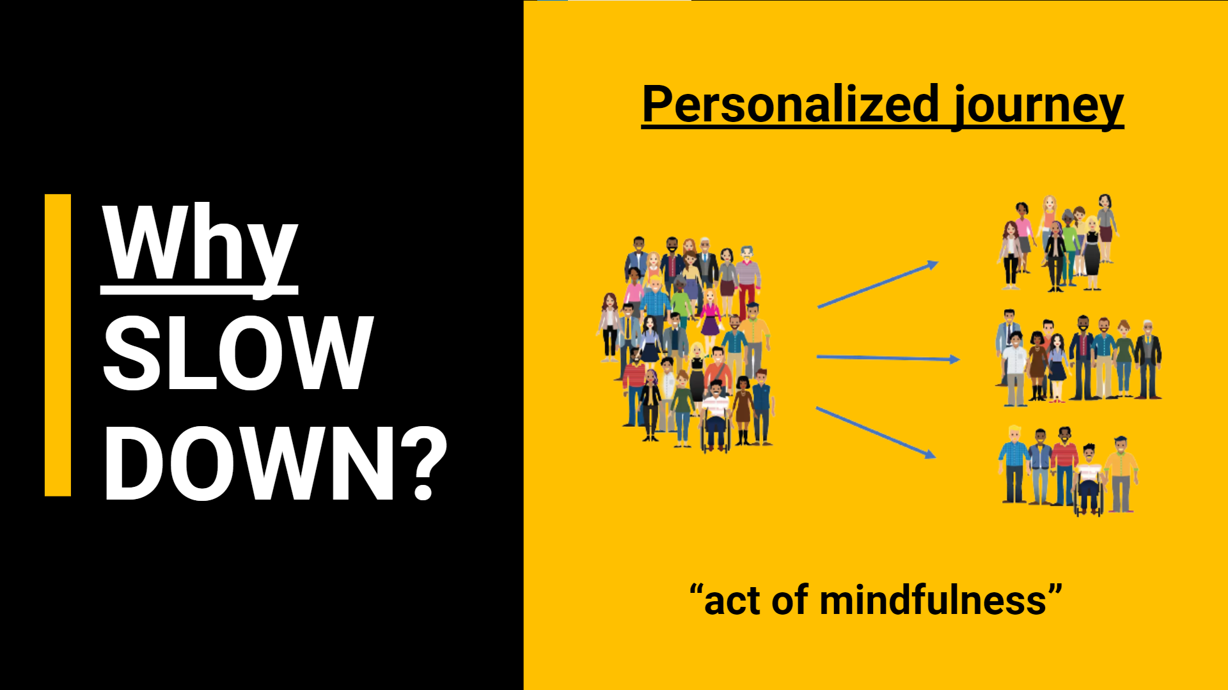
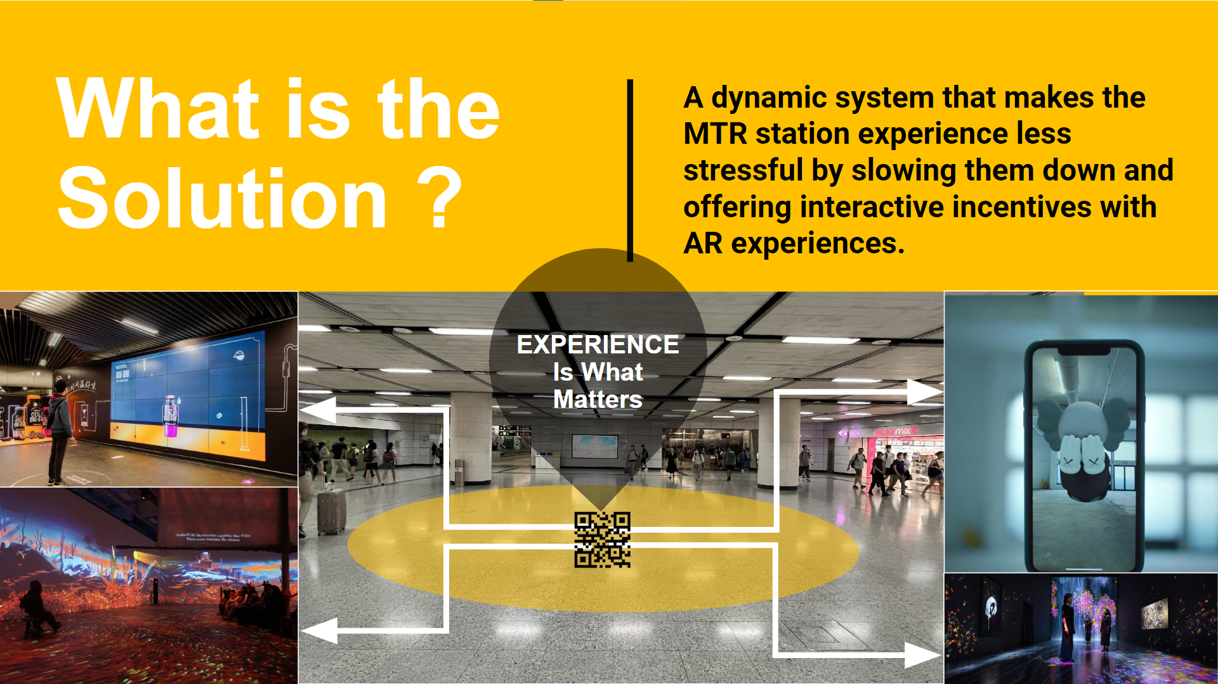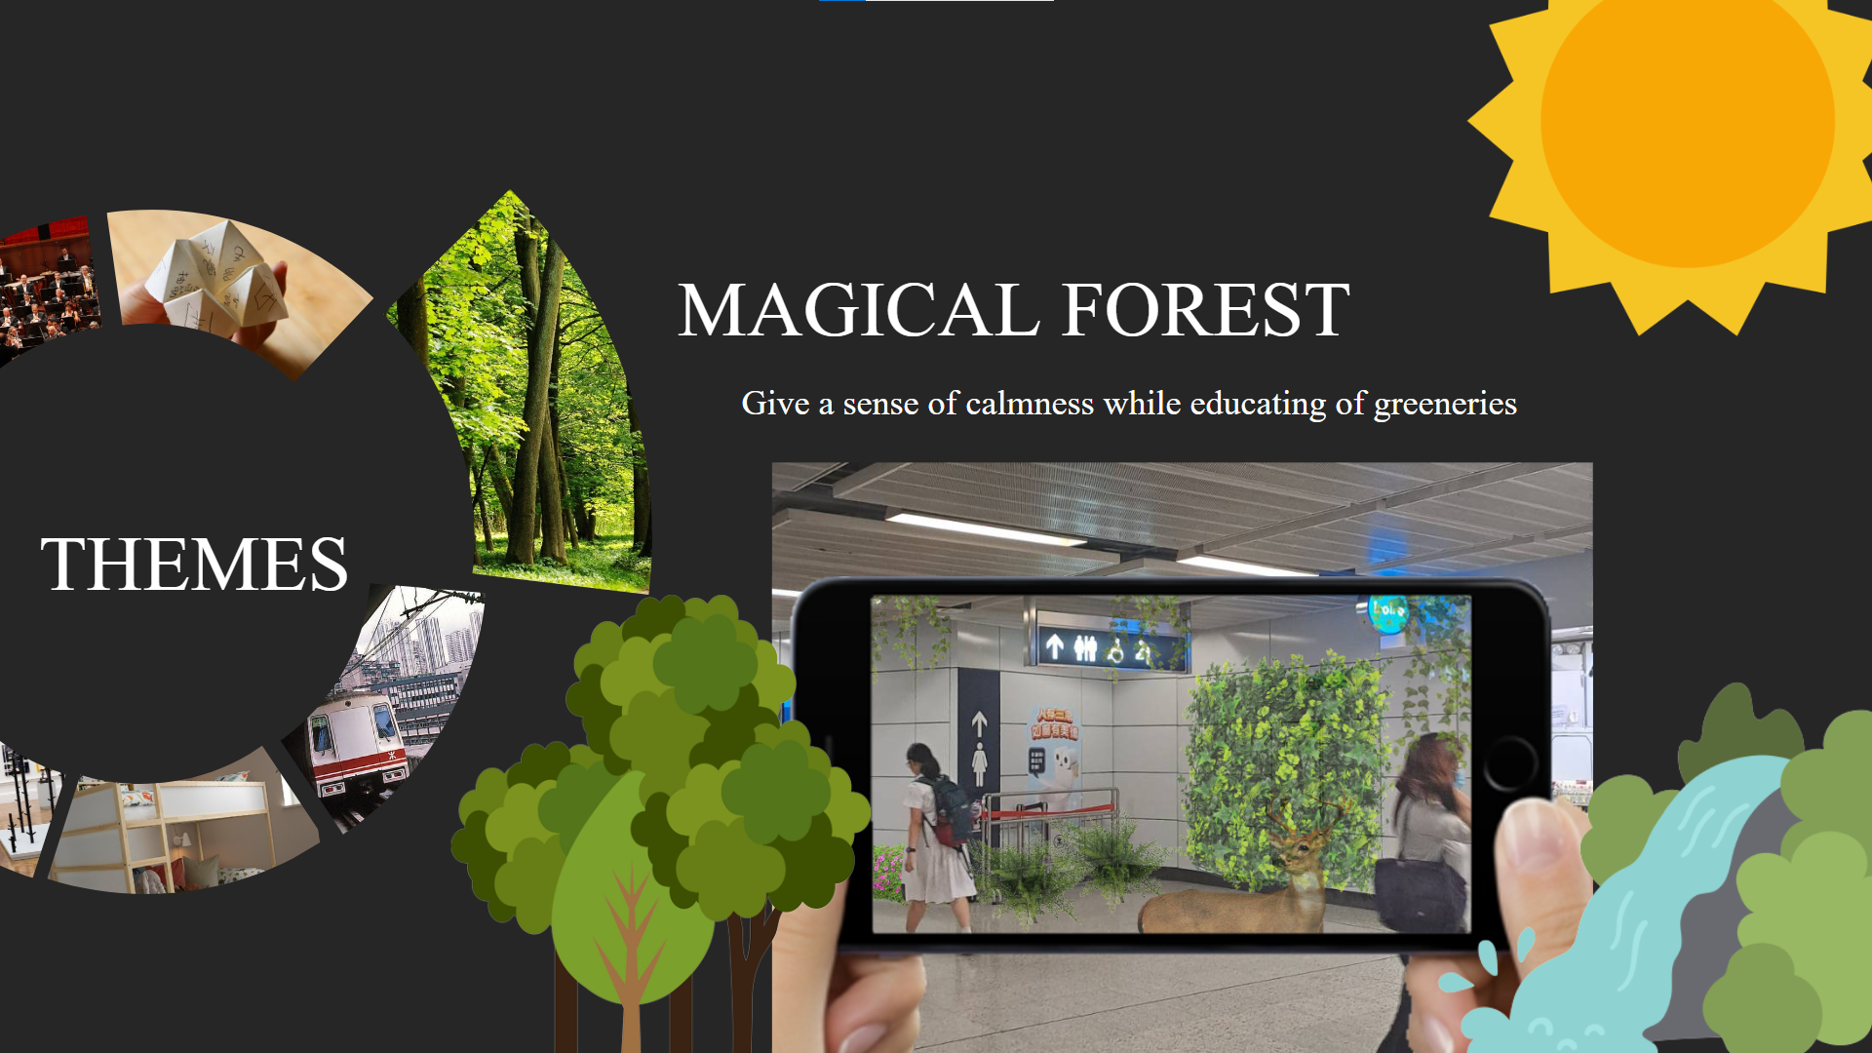

Team 7
MTR GO
An expressway with lockers along its path for commuting that also provides daily necessities and meals ordered through an app
Soad Mana, Wing Hei Lam, Xiangyu Li, Reshad Rabbi, Caleb Othniel Vigknesvaran

MTR GO introduces MTR Expressway, a platform providing necessary products through a convenient app integrated system with quick pick-up collection points. Automated stores are to be distributed along the MTR mall paths, designed as pick up zones. The service is easily deployable through the existing MTR app and simply provides daily necessities, products which can be picked up quickly throughout different malls and pick up station during a commuter’s journey, saving time and enhancing convenience, avoiding the hassle of getting through crowds and having to fetch for the right products throughout the whole mall.

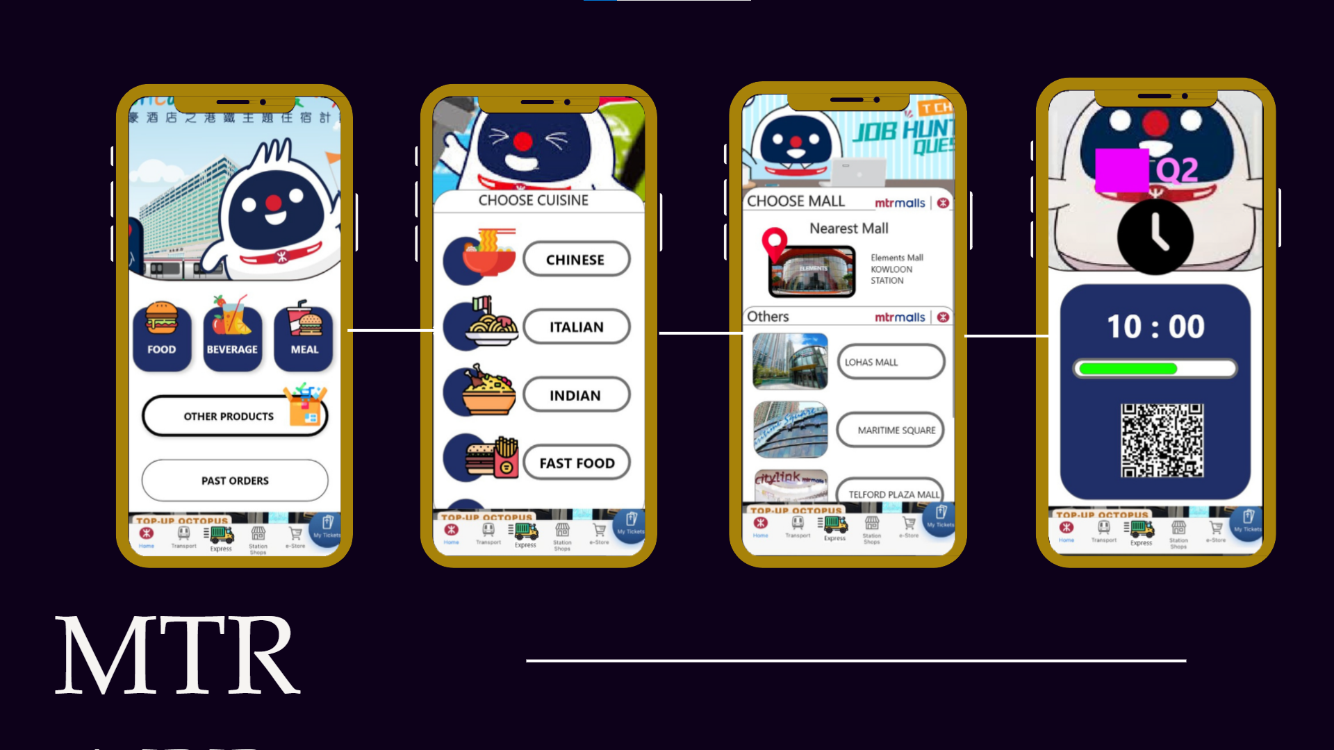
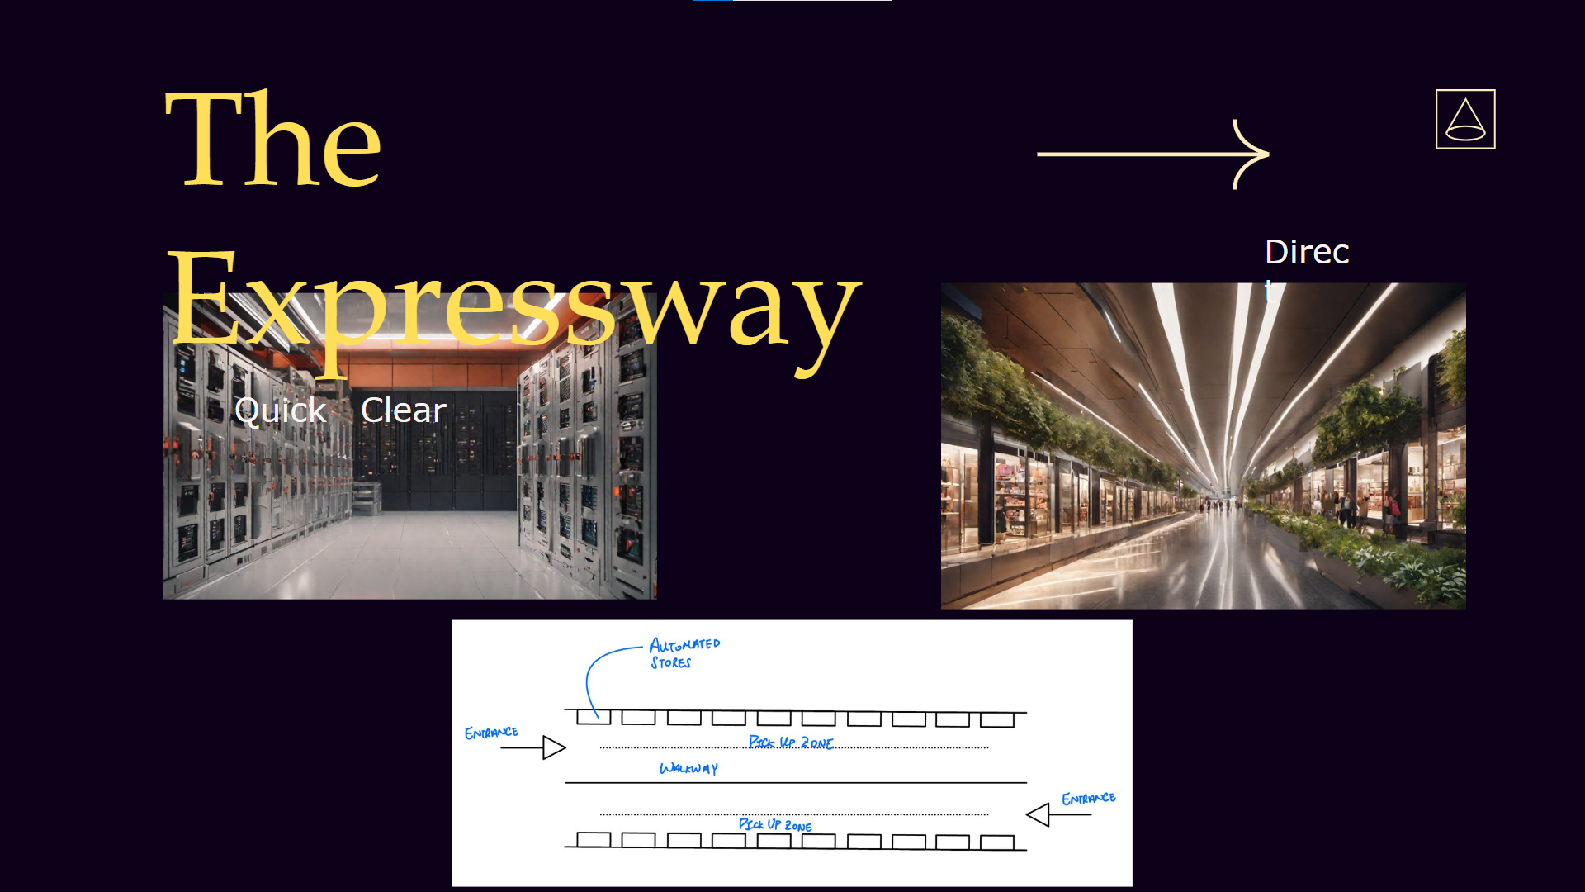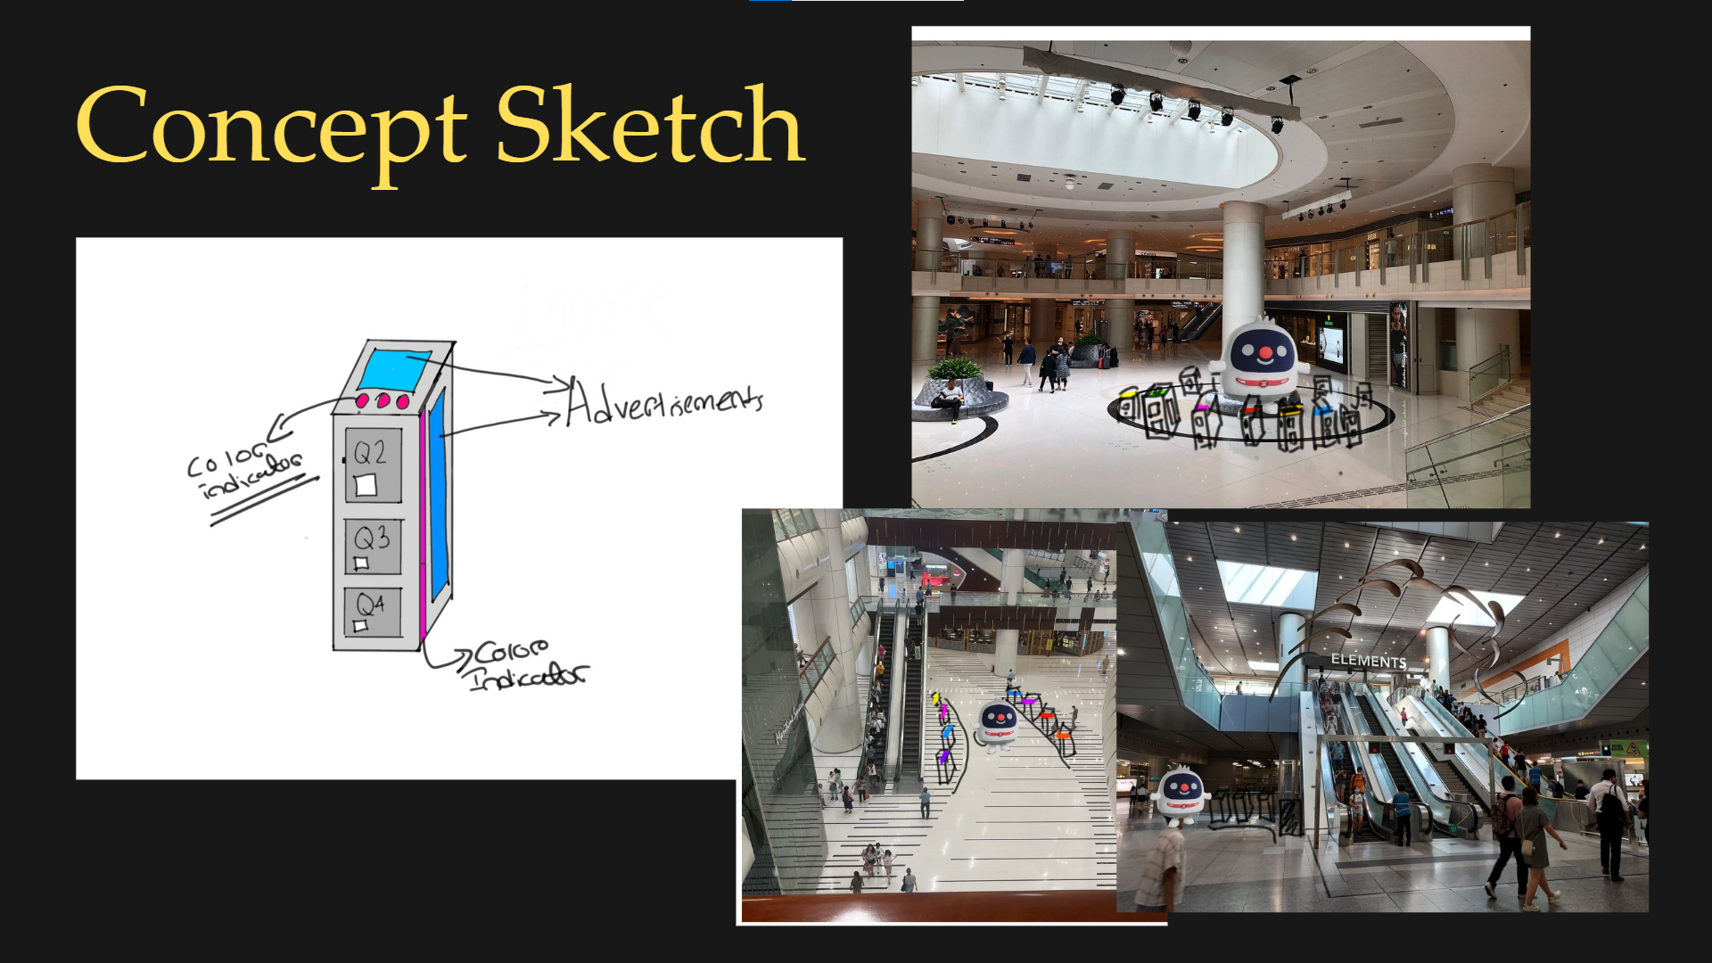

Team 8
Flow
Addition of the AR in-station mapping, virtual assistance, and dynamic pricing features to the existing MTR App for better station navigation, user experience and potentially easing the problem of overcrowding.
Geoffrey Nyakiongora, Hei Julius Choy, Wan Yee Lo, Natalie Sutrisno, Shun Hang James Yau

The solution for better navigation and easing overcrowding lies within the existing MTR app which, with additional features, can manage crowd flow in stations by:
- Increasing navigability
- Better Commuter Distribution
- Creating Incentives to Choose Another Route
- Happier User Journey Experience

How can the MTR manage system design to allow maximum flexibility and the capability to adopt new technology to drive better safety, customer experience and ESG targets without significant impact to project cost and programme?
- Enhancing the MTR App as the Most Powerful Mass Transit App Worldwide!
- Addition of the AR in-station Mapping, Virtual Assistance & Dynamic Pricing Features to the Existing MTR App for Better Station Navigation, User Experience and Potentially Easing the Problem of Overcrowding.

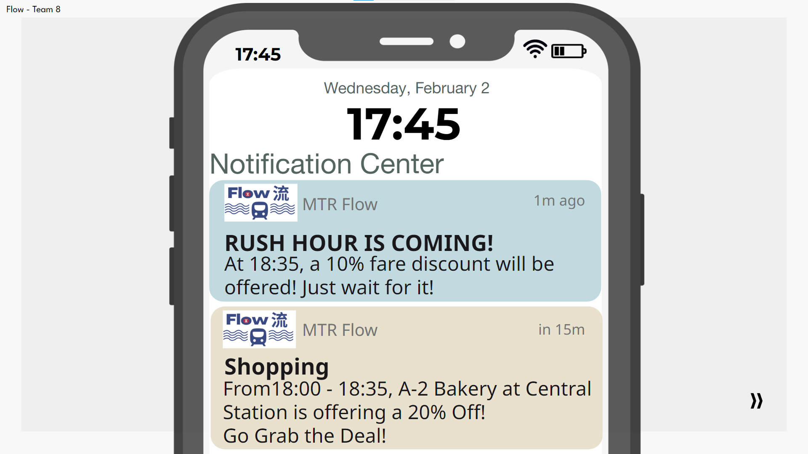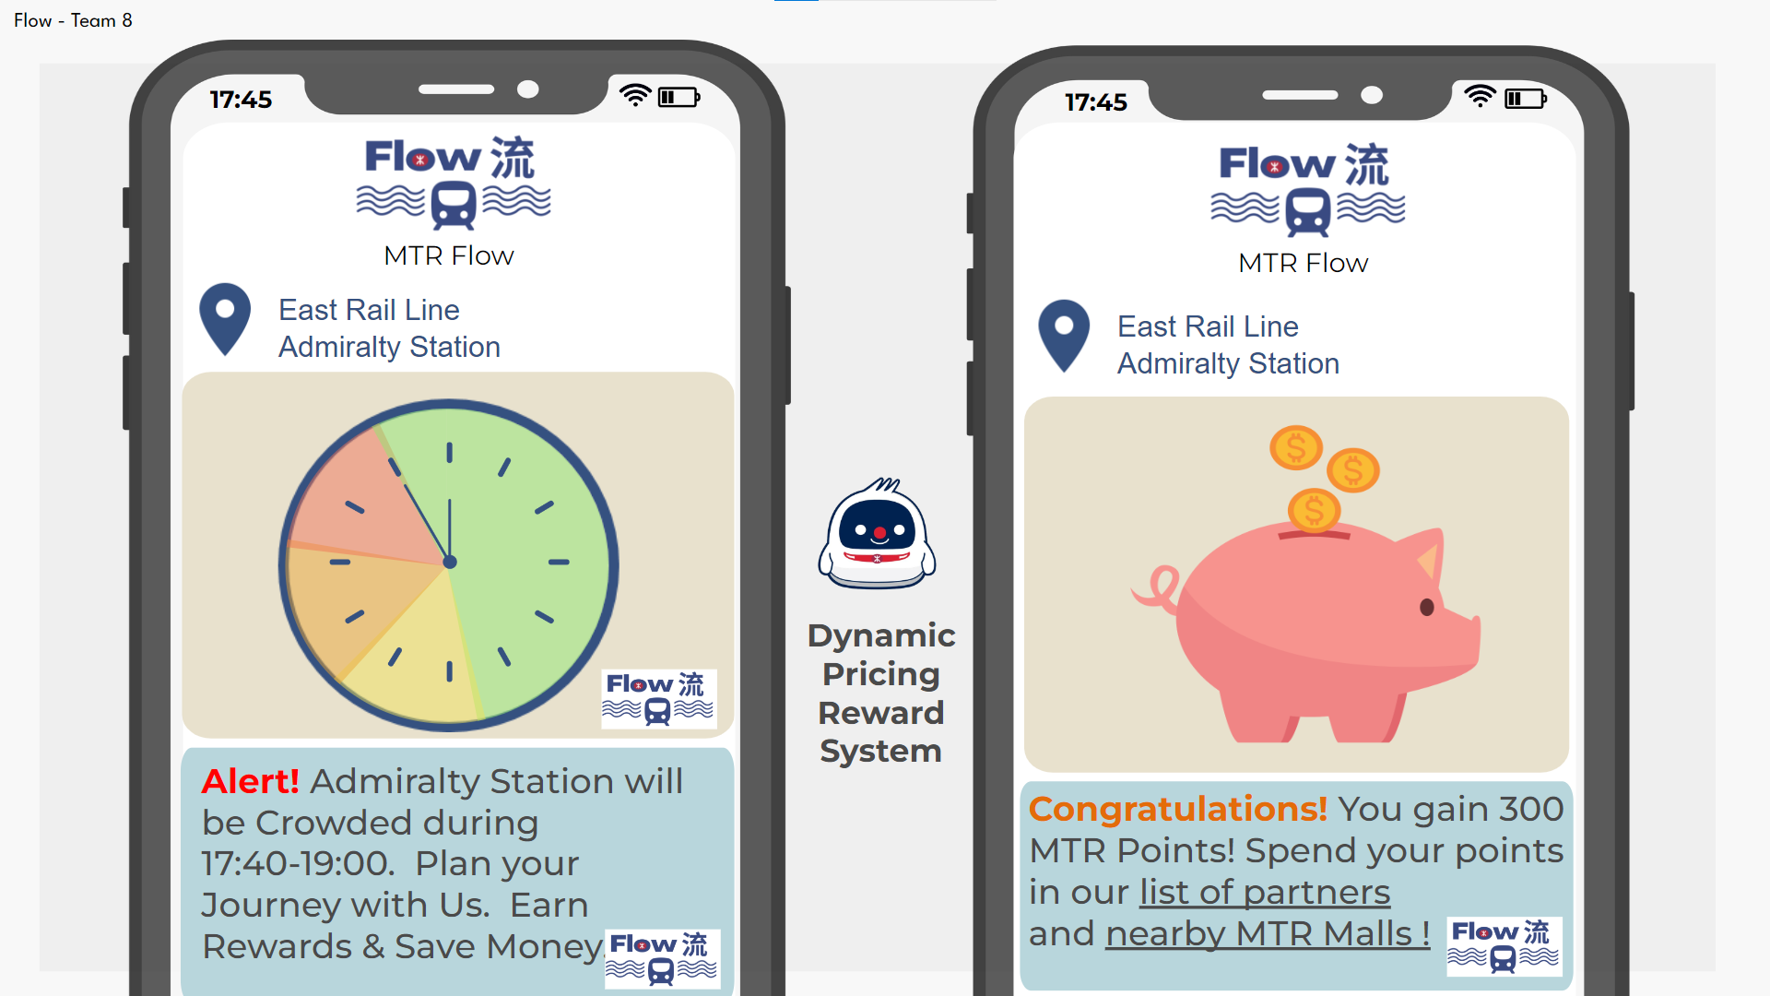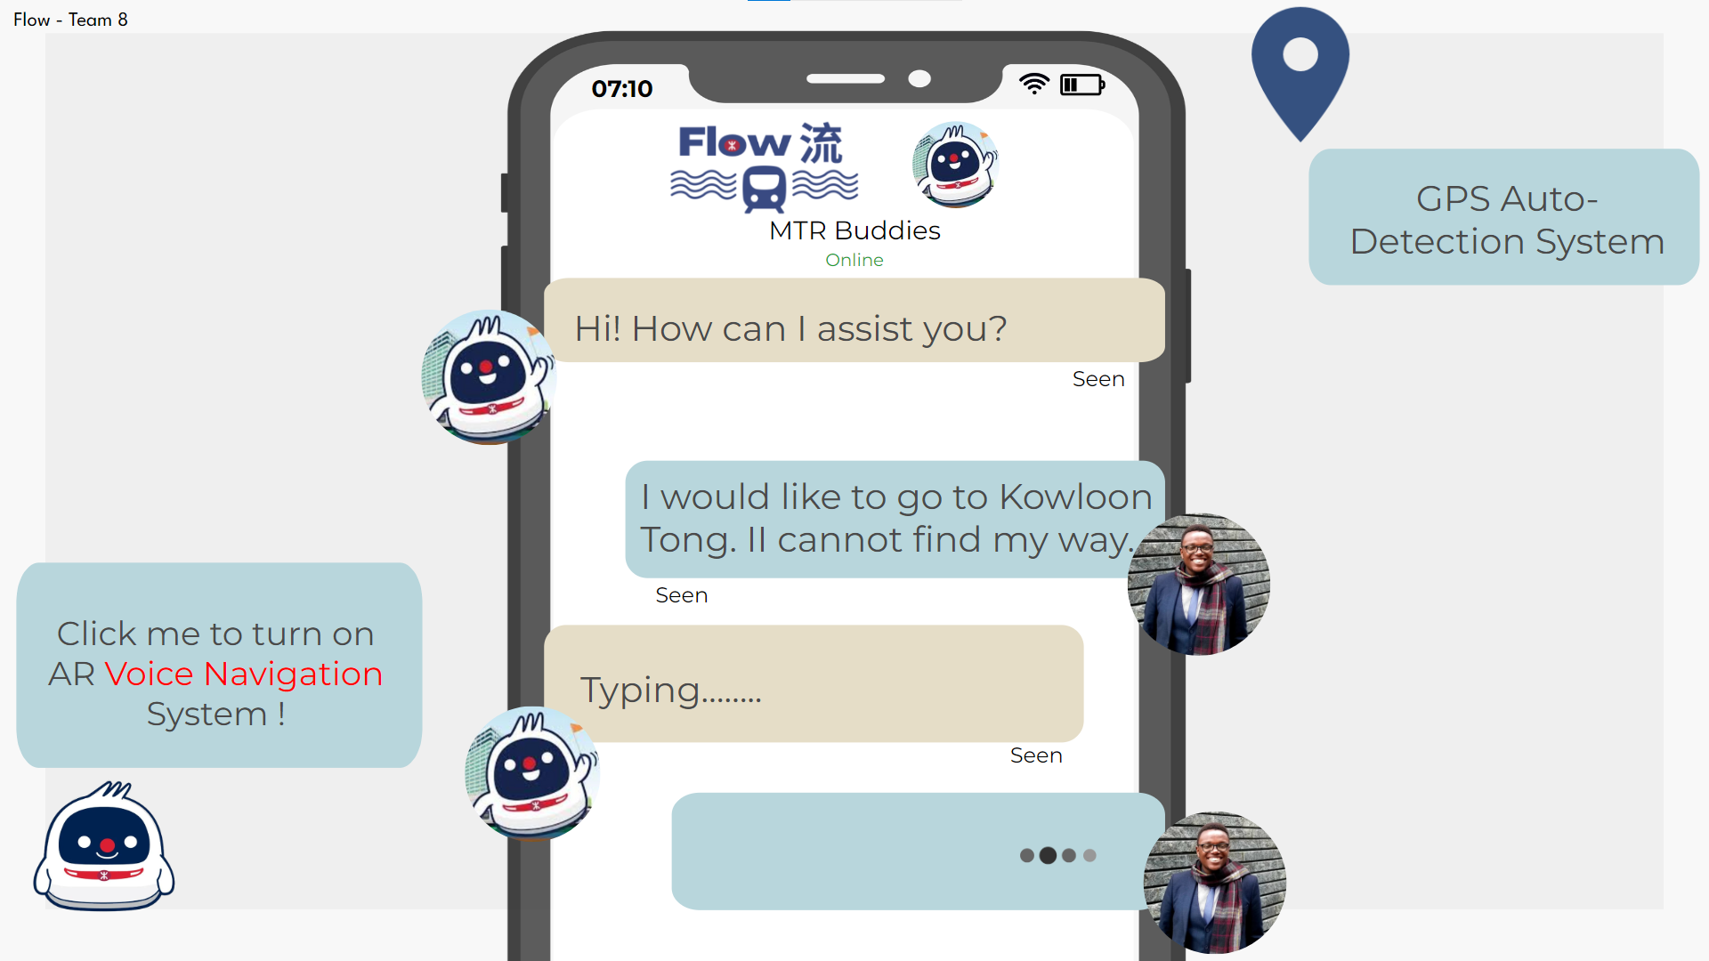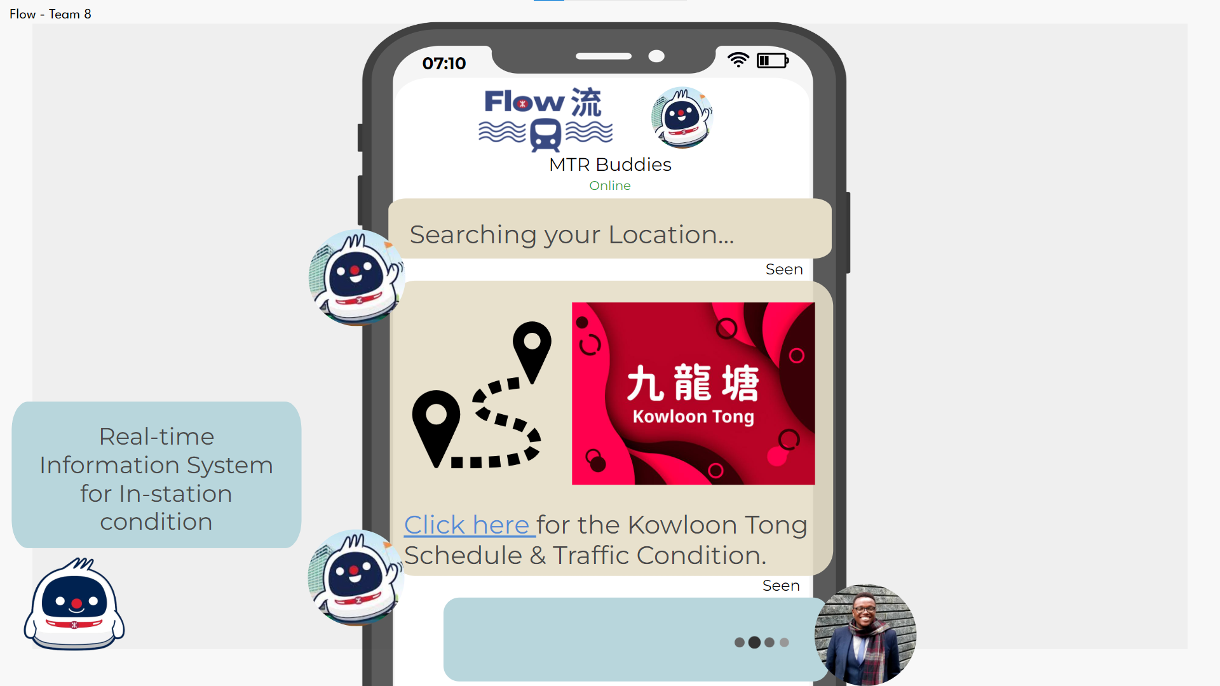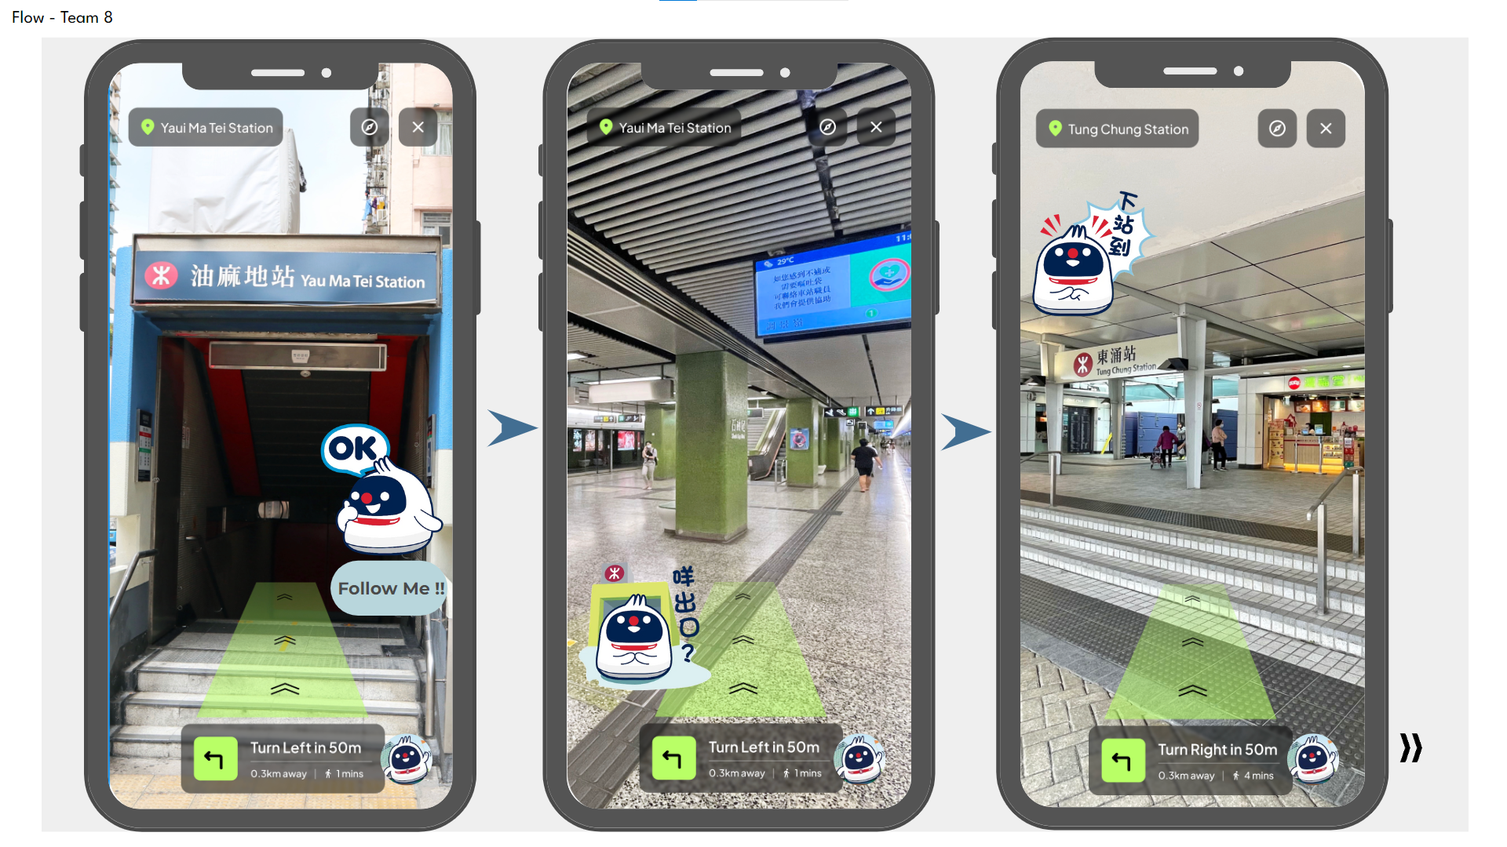

Team 9
Pot+Luck
Introduce Hong Kong local business to MTR shopping malls.
Gabriel Andrade, Timothy Joseph Henares, Hiu Kwan Yeung, Zerui Li

The underutilised walkways and other spaces can become pop-up spaces. These pop-up spaces will be for LOCAL BUSINESS to create new relationships with both the local and international markets. The strategy not only caters for diversity in the malls but also allows these businesses to expand at low barriers to entry. MTR will help bring exposure to local business at a low-entry fee in “high traffic spaces” like mall corridors. These shops will move every 6 months based on performance, while rent will be set at a 18% sales revenue share with the MTR mall.

Team 10
ConnectCBD
Revolutionising CBD commuting with flexible, comfortable, and sustainable multi-modal transit integrated with existing infrastructure and digital platforms.
Cheng-Hsin Chan, Wai Ho Ricco Tsang, Lok Hin Lam, Yulong Wang, Elizabeth Andrea Yusuf

By replacing signalling systems with ETCs, we can reduce distance between trains, allowing more trains to run, accommodating more passengers per hour, and alleviating overcrowding. However, implementing ETCS takes a long time. In the meantime, leveraging on this existing infrastructure can enhance system flexibility for a sustainable future. By collaborating with bus companies, we can create express routes during rush hours between CAB & HOK and accommodate more customers in the MTR. Our Pricing Strategy attracts passengers while ensuring that all parties profit. Bus fares remain low and the profit sharing with MTR and subsidies compensate extra operating costs.

